Work identification and scheduling | MSP-04
Maintenance System Procedure | MSP-04
This procedure sets out how the requirement for maintenance work is identified and scheduled.
Procedure
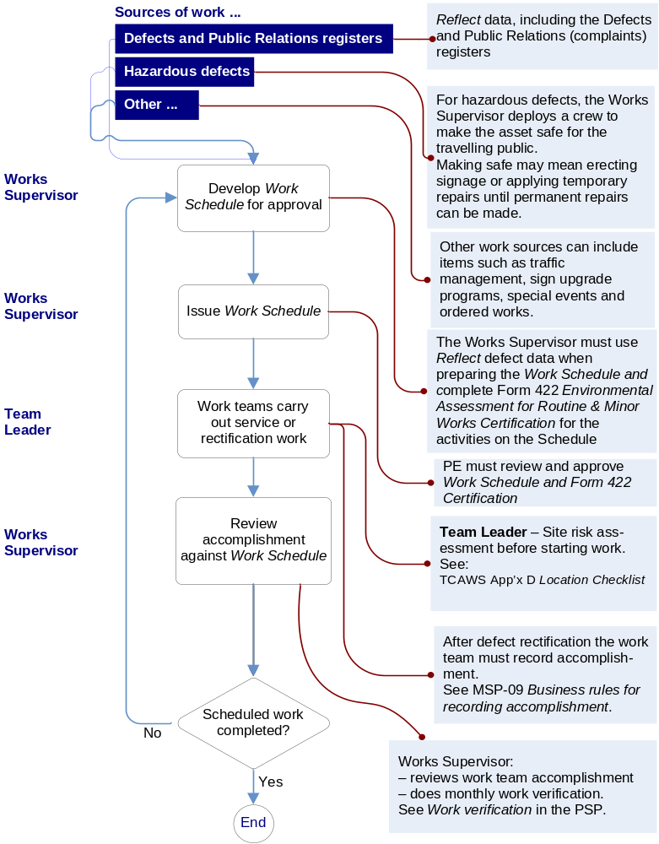

Project Coordinator

Project Coordinator

Team Leader

Project Coordinator

Team Leader – Site risk assessment before starting work.
Project Coordinator must review and approve Work Schedule and Form 422 Certification.
Project Coordinator:
- reviews work team accomplishment.
The Project Coordinator must use Reflect defect data when preparing the Work Schedule and complete Form 422 Environmental Assessment for Routine & Minor Works Certification for the activities on the Schedule.
For hazardous defects, the Supervisor deploys a crew to make the asset safe for the travelling public.
Making safe may mean erecting signage or applying temporary repairs until permanent repairs can be made

